Based on Samuel and Tom report
Reference 1: Kayaku SU-8 2075 Process Recipe & Spin Curve — NANYTE
Reference 2: Kayaku SU8 2075 photoresist - Overall solution for microfluidic chip laboratory
Reference 1
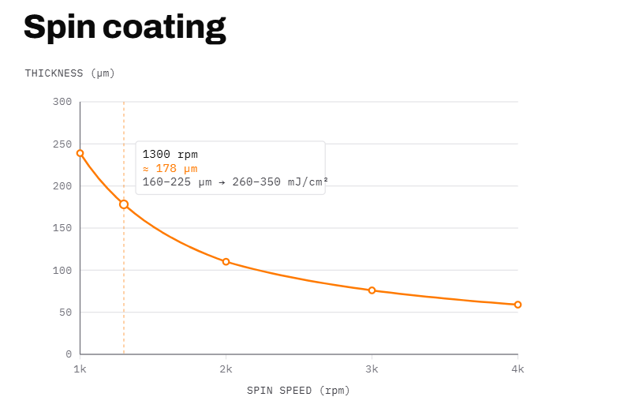
Reference 2

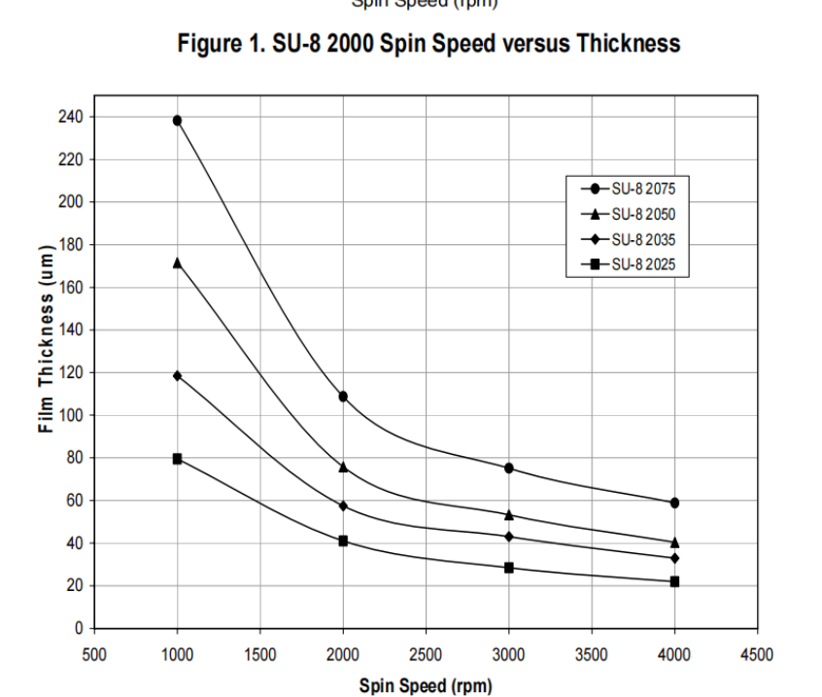
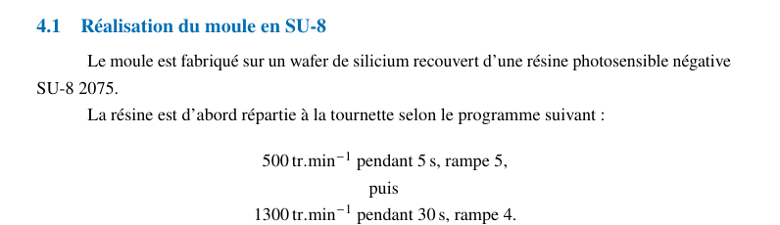
500 rpm Spread cycle Uniformly spreads the viscous photoresist from the center to the edges while eliminating bubbles, without splashing material off the wafer. This step has no impact on the final film thickness
1300 rpm Spin cycle Reaches the target rotational speed that balances centrifugal forces against resist viscosity and solvent evaporation. This final speed alone determines the resulting channel height ($h$).
From reference 1 1300rpm 178 um thickness
From reference 2 1000 rpm around 170-180 um
In practical the variation can be $±10 μm to ±20μm$.
For my next process, I will take the experimental measure of thickness for the future.
Method to have the same velocity for different ID
We need to have this equality:

